
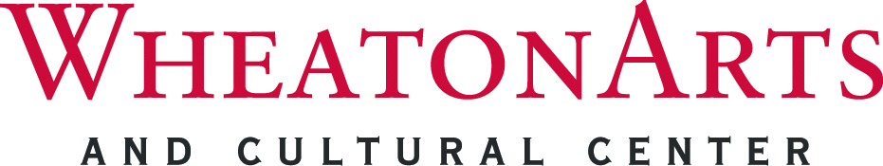
CONTACT: Cathy Nolan, Chief Operating Officer
TEL: (856) 825-6800, ext. 115 / FAX: (856) 825-2410
E-MAIL: cnolan@wheatonarts.org

WHEATONARTS MID-WINTER ANTIQUES SHOW FEBRUARY 6 AND 7

MILLVILLE, NJ – Wheaton Arts and Cultural Center will host the Mid-Winter Antiques Show on February 6 and 7, 2016. This show attracts over 40 quality dealers and hundreds of visitors from the Mid-Atlantic region. Located in the Event Center, attendees explore a wide selection of antique furniture, books, ceramics, glass, jewelry, linens, memorabilia, paper, toys, pottery, primitives, and vintage accessories.
Show hours: Saturday, February 6 – WheatonArts Members Preview at 9:30 a.m. General Public from 10 a.m. to 5 p.m.; and Sunday, February 7, 10 a.m. to 4 p.m. Admission is $5.00 per person. Food and refreshments will be available for purchase in the Event Center. The award-winning Museum Stores will be open during the both days of the show.
WheatonArts is a participant in Museums on Us®, a customer-benefit program offering free admission for a Bank of America cardholder to the finest museums and cultural institutions from coast to coast on the first full weekend of each month of 2016. Cardholders will receive admission to the show.
In January, February and March the Museum of American Glass and the Artist Studios are closed. The Museum Stores are open Friday, Saturday and Sunday only, 10 a.m. to 5 p.m., during these three months. No ticket required. WheatonArts returns to its six-day operating schedule (Tuesday through Sunday, 10 a.m. to 5 p.m.) on April 1.
For more information WheatonArts, call 1-800-998-4552 or 856-825-6800, or visit wheatonarts.org.

WheatonArts strives to ensure the accessibility of its exhibitions, events and programs to all persons with disabilities. Provide two weeks notice for additional needs. Patrons with hearing and speech disabilities may contact WheatonArts through the New Jersey Relay Service (TRS) 800-852-7899 or by dialing 711.
Funding has been made possible in part by the New Jersey State Council on the Arts, a Partner Agency of the National Endowment for the Arts, the Geraldine R. Dodge Foundation, the National Endowment for the Arts and the New Jersey Cultural Trust. WheatonArts receives general operating support from the New Jersey Historical Commission, Division of Cultural Affairs in the New Jersey Department of State, and is supported in part by the New Jersey Department of State, Division of Travel and Tourism.

###

