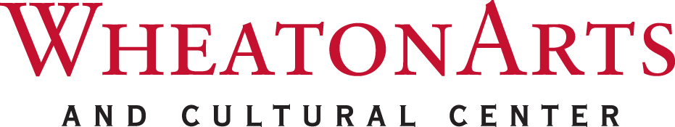
CONTACT: Janet Peterson, Marketing and Public Relations Director
TEL: (856) 825-6800, ext. 108 / FAX: (856) 825-2410
E-MAIL: jpeterson@wheatonarts.org

NEW JERSEY STATE COUNCIL ON THE ARTS IN CO-SPONSORSHIP WITH WHEATONARTS ANNOUNCE FOLK ARTS MASTER ARTIST AWARD

MILLVILLE, NJ – New Jersey’s diverse population yields an impressive array of cultures, each represented through traditional and folk arts.
Folk arts and crafts are those most often learned as part of the lifestyle of a community whose members share identity based upon ethnic origin, religion, occupation, or geographical region. Highly varied, these traditions are shaped by the aesthetics and values of the community and are passed from generation to generation.
For 20 years, the New State Council on the Arts (NJSCA) has supported folk arts programs, projects and individual folk artists in order to share these impressive cultural treasures with an even broader community.
To commemorate the 20th anniversary of the Folk Arts Program, the New Jersey State Council on the Arts, in co-sponsorship with WheatonArts, is offering a unique opportunity--the Folk Arts Master Artist (FAMA) Award. The FAMA Award will honor one exceptional master folk artist who has significantly impacted New Jersey’s diverse cultural and artistic landscape. The award recognizes lifetime achievement, artistic excellence, and contributions made to New Jersey’s folk and traditional arts through community engagement. The NJSCA will award $10,000 to one New Jersey Master Folk Artist.
Who May Be Nominated: A master folk artist as defined by the following: “someone who has learned a traditional art as part of community life and has attained a high level of excellence in the eyes of other community members.”
Process and Timeline: Master folk artists are nominated by individuals or organizations by the application deadline of October 31, 2015. Nominations meeting all eligibility requirements will be reviewed and evaluated by an independent peer panel. At the NJSCA public meeting in December 2015 (tentative), the Council will announce the recipient of the FAMA Award.
Eligible Nominees Must: Have been a resident of New Jersey for at least one year at the time of nomination (the award is subject to verification of New Jersey residency). Remain a New Jersey resident during the grant award period (January 1 – December 31, 2016).
Nominee Applications will be reviewed using the following criteria: Demonstrated artistic excellence, as recognized by the field. Actively engaged in continuing artistic accomplishment. Sustained history of folk arts activity within New Jersey. Proven contributions to his/her community through public presentation, advocacy, and/or education of traditional artistic work. Record of significant contributions to preserving and perpetuating the folk and traditional arts.

- more -
Page 2 of 2 - NEW JERSEY STATE COUNCIL ON THE ARTS IN CO-SPONSORSHIP WITH
WHEATONARTS ANNOUNCE FOLK ARTS MASTER ARTIST AWARD

Nominees for the FAMA Award must submit all of the required items as specified by
October 31, 2015. Incomplete nominations will not be considered.
For questions regarding the application, contact: Kim Nguyen, Program Officer – Folk Arts,
New Jersey State Council on the Arts, at 609.292.4495 or Kim.Nguyen@sos.nj.gov; or Iveta Todorova-Pirgova, Director of Education and Cultural Studies, Wheaton Arts and Cultural Center, 856.825.6800, ext. 131 or email ipirgova@wheatonarts.org.
For more information about NJSCA visit http://www.state.nj.us/state/njsca. For information about WheatonArts, call 1-800-998-4552 or 856-825-6800, or visit wheatonarts.org.
With a history spanning four decades, WheatonArts has earned regional, national and international recognition for its unique collections and programs. WheatonArts is home to the Museum of American Glass with one of the most comprehensive collections of American glass in the world…from the first glass bottles made in America to celebrated works by Dale Chihuly and other contemporary artists who work in glass. In the Studios, visitors watch artists demonstrate the art of glassmaking, ceramics and flameworking. The Center also operates award-winning Museum Stores. The Creative Glass Center of America (CGCA), a residency program, has hosted over 330 Fellows, in one of the nation’s first public-access, amphitheater-style hot glass studios. CGCA with other studio programs exemplify a dynamic community of resident and guest artistsfrom around the world, who share skills and vision with public audiences, and provide unique educational programming for both children and adults. WheatonArts presents special exhibitions, programs, workshops, performances and several weekend festivals throughout the year.
WheatonArts strives to ensure the accessibility of its exhibitions, events and programs to all persons with disabilities. Provide two weeks notice for additional needs. Patrons with hearing and speech disabilities may contact WheatonArts through the New Jersey Relay Service (TRS) 800-852-7899 or by dialing 711.
Funding has been made possible in part by the New Jersey State Council on the Arts, a Partner Agency of the National Endowment for the Arts, the Geraldine R. Dodge Foundation, the National Endowment for the Arts and the New Jersey Cultural Trust. WheatonArts receives general operating support from the New Jersey Historical Commission, Division of Cultural Affairs in the New Jersey Department of State, and is supported in part by the New Jersey Department of State, Division of Travel and Tourism.

###

